Canvas Parent Instructions for Monitoring

How do I sign up for a Canvas account as a parent?
Parents can sign up as an observer in Canvas. Observers can link their Canvas account to their student's account so they can see assignment dues dates, announcements, and other course content. Observers can view the course content but cannot participate in the course.
This lesson is for parents who do not have a Canvas account and want to observe their students in their courses.
If you already have an account from your student's institution, log in to Canvas using the credentials given to you.
Notes:
  - If the registration banner is not available in the login page, the institution has not enabled this feature. Please contact your student's institution for assistance. (If you are a Canvas admin, learn how to enable the banner through Canvas authentication.)
  - To observe a student, you must know the student's Canvas username and password.
  - The student must be enrolled in the course and must accept the course invitation before you can
sign up to observe the student. If you receive an invalid username or password message during the signup process and the student's credentials are correct, check with the student to verify that he or she has received and accepted the course invitation.
  - Once you have an account, you may be able to view student information through the Canvas Parent app. Access to the Canvas Parent app is controlled by the student's institution. If you already have an account from your student's institution as an observer, you can always view student information through the Canvas Parent app.
Open Canvas URL
In a browser window, enter the institution's Canvas registration URL (e.g. canvas.instructure.com).
Click to Register

1
How do I sign up for a Canvas account as a parent?
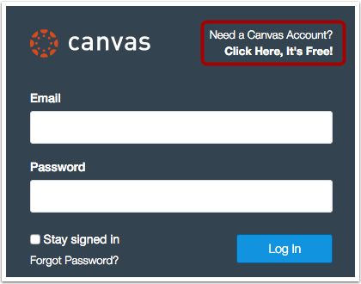
Click the account link at the top of the page.
Sign Up As a Parent (Free Account)
2
How do I sign up for a Canvas account as a parent?
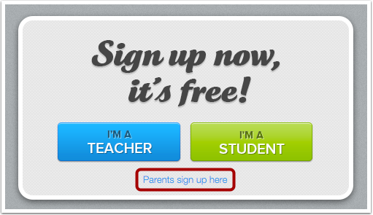
Click the Parents sign up here link.
Enter Signup Details
3
How do I sign up for a Canvas account as a parent?
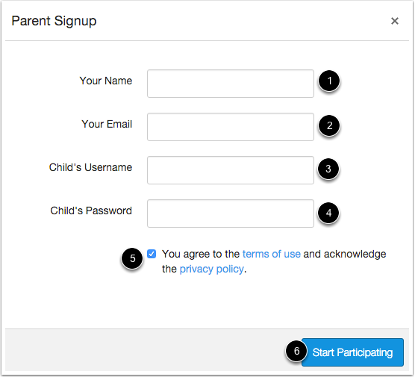
Enter the following information:
1. Enter your name in the name field.
2. Enter your email in the email field.
3. Enter your child's username in the child's username field.
4. Enter your child's password in the child's password field.
5. Agree to the terms of use by clicking the You agree to the terms of use check box. 6. Click the Start Participating button.
Use Canvas
4
How do I sign up for a Canvas account as a parent?
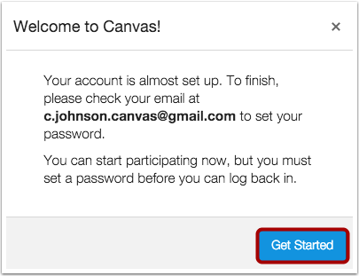
While your account is not entirely set up, you can begin participating in Canvas immediately by clicking the Get Started button. To finish registering for Canvas, log into your email account.
Complete Registration Process
5
How do I sign up for a Canvas account as a parent?
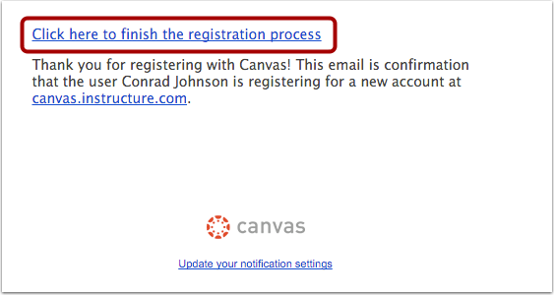
Open the email from Instructure Canvas. Click the link provided to visit the provided URL and complete the registration process.
Register for a Parent Account
6
How do I sign up for a Canvas account as a parent?
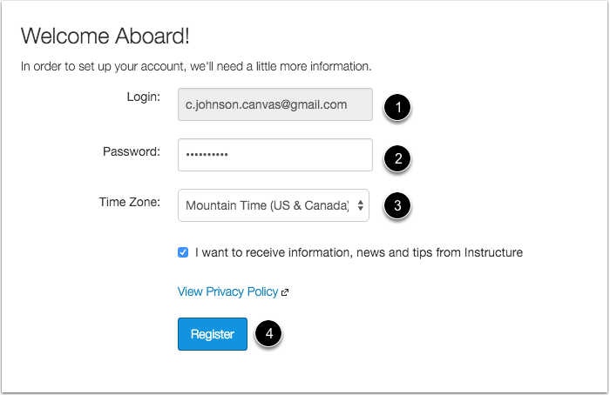
To complete the registration process fill out the following fields:
1. Verify your email in the login field.
2. Set your password by typing in the password field.
3. Set your timezone by selecting the time zone drop-down menu.
4. Click the Register button. You will be redirected to the Canvas URL login page for your account.
View User Dashboard
7
How do I sign up for a Canvas account as a parent?
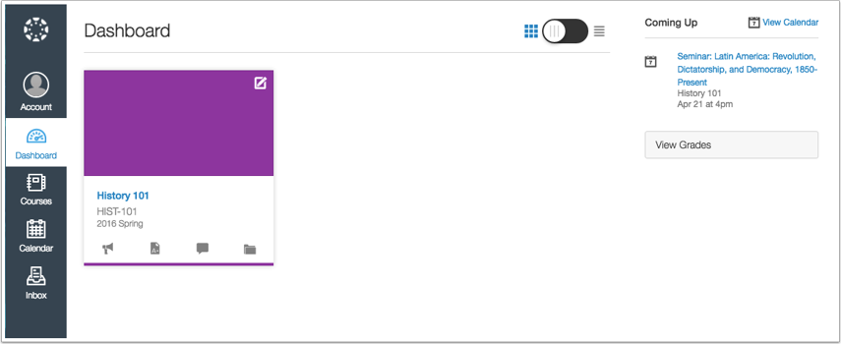
View the user dashboard for your Canvas account.
View Course
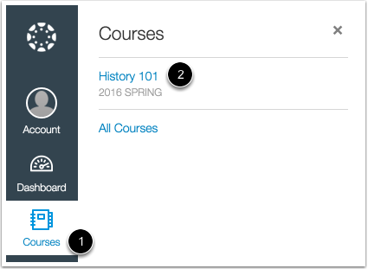
In Global Navigation, click the Courses link [1], then click the name of the course [2].
8
How do I sign up for a Canvas account as a parent?
Learn how to observe additional students in your account.

